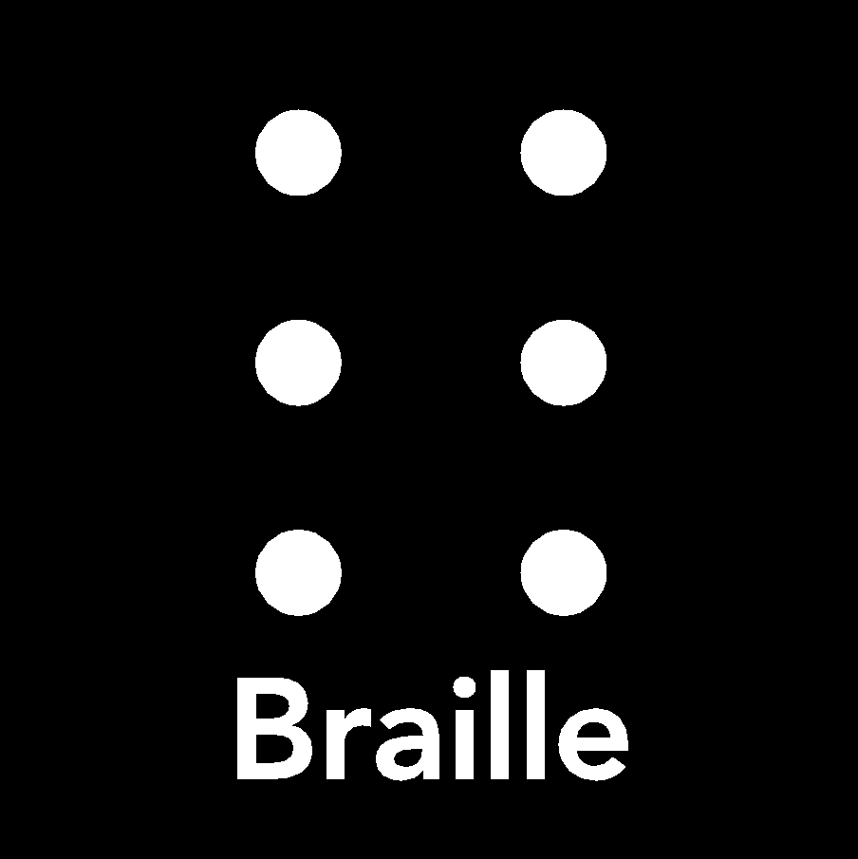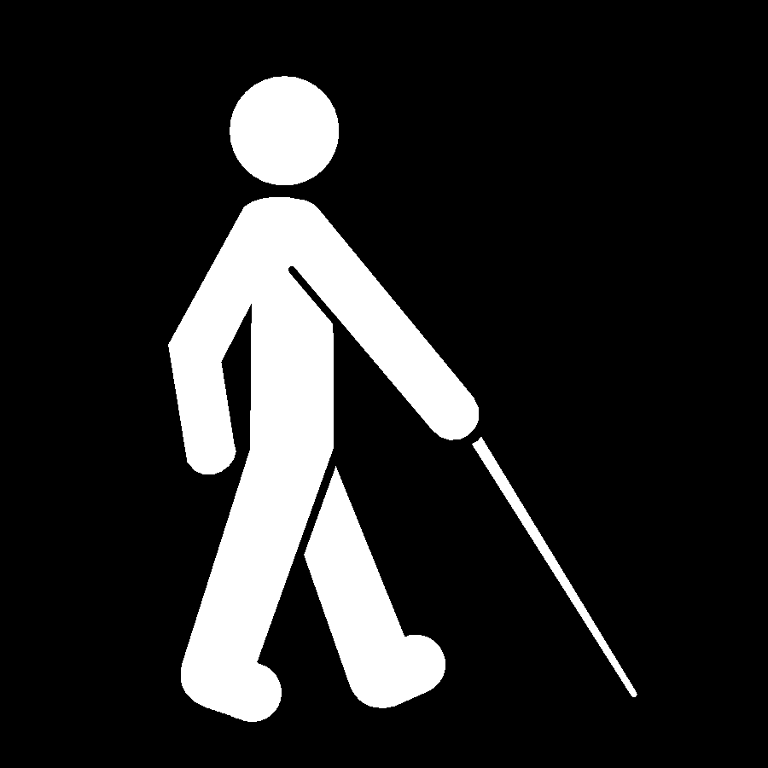

Students With Blindness/Visual Impairments
Visual impairments vary greatly. Most persons who are legally blind have some vision. Those with low vision may rely on residual vision and adaptive equipment.

Things To Keep In Mind
- Students who have visual impairments should participate fully in classroom activities and group work. Obstacles in laboratory classes, field trips, and internships can be minimized with planning and adaptive equipment.
- Adaptive or specialized equipment may be needed for note-taking (i.e., tape recorder, pocket Braille, or laptop computer).

Things You Might Do
- Provide handouts, reading lists, or syllabi in advance so that students can transfer items into alternate formats.
- Seat the student in the front of the class.
- Face the class when speaking.
- Convey in spoken words whatever is on the chalkboard, overhead, or video monitor.
- Assist the DSS staff by locating copies of the text, etc.
- Provide copies of lecture notes where appropriate, and/or permit note-taking devices.
- If a student cannot carry out a specific task, consider an alternative assignment.
- Plan field trips and special projects well in advance and alert the field supervisor to any necessary adaptations.
- Help arrange testing accommodations (i.e., readers, scribes, enlarged print, or computer software with speech access).
- Request a classroom with a white board and use black markers.
- Assist student with emergency evacuation, if needed.

Accommodations To Consider
- Note-takers, readers, scribes, or tape recorders in class
- Assistance obtaining recorded textbooks, other class materials
- Classroom relocation, if needed
- Use of manipulative learning aids whenever possible
- Use of black markers with white boards
- Classroom adaptations and technology
- Exam accommodations (extended test time, readers, scribes, and/or appropriate assistive technology equipment)

